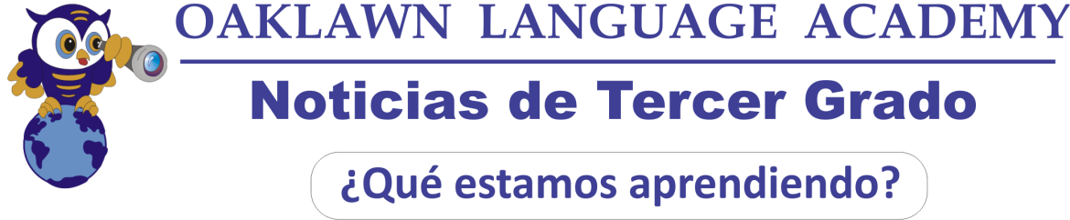
Matemáticas: Este mes estaremos trabajando cuántas decenas hay en un número y problemas sobre colecciones y viajes incluyendo problemas de dos pasos. Seguiremos repasando “aproximar números a la decena y a la centena más cercana y problemas relacionados con la hora. Deben saber leer el reloj. Para practicar matemáticas en casa los estudiantes pueden ir a Ten Marks, compass learning (Math) y a la Weebly de tercer grado http://oaklawnthirdgrade.weebly.com/

Nov. 2016

Inglés: Este mes estaremos trabajando La idea principal de textos de no-ficción y detalles que apoyan la idea principal. Estaremos enseñando acerca de las características de los textos y comprensión lectora.

Ciencias: Los estudiantes aprenderán acerca de la energía. Ellos aprenderán acerca de los conductores y aislantes y como controlar la cantidad de calor. Los estudiantes aprenderán como la energía cambia el estado de la materia.

Sociales: Este mes estaremos aprendiendo acerca de los tres tipos de gobierno y los líderes de cada gobierno. Vocabulario: gobierno federal, gobierno estatal, gobierno local, presidente, gobernador, alcalde. Los estudiantes pueden ir a la weebly de tercer grado para repasar el vocabulario.

Español: Los estudiantes empezaron a usar su nuevo libro de trabajo donde practicarán gramática y escritura. Seguiremos escribiendo las preguntas OLA habla español. También trabajaremos en gramática (verbos gustar, ser y estar) y describiendo personas y cosas. Vocabulario para describir, adjetivos. También trabajaremos en comprensión lectora de un texto con preguntas. Por favor vayan a la weebly de tercer grado para ver videos y canciones y para practicar vocabulario pueden ir a www.quizlet.com

Información Importante: Los estudiantes necesitan traer sus materiales cada día. Por favor asegúrense de mirar la Carpeta de los Jueves y firmar exámenes y papeles importantes y regresarlos el siguiente día. Si los padres no firman las evaluaciones los estudiantes no pueden hacer el re-take.

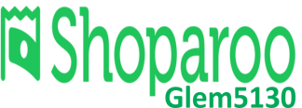  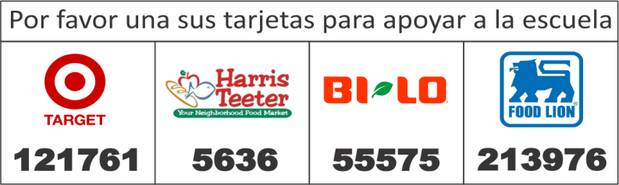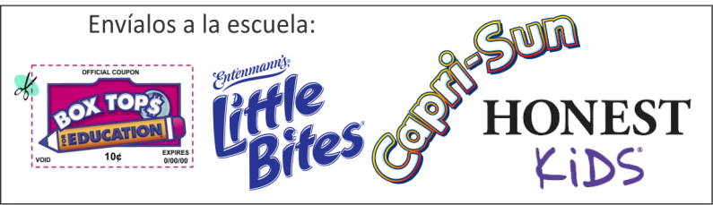 | FECHAS IMPORTANTES  8 Teacher Workday  10 Los reportes van a casa  11 No hay escuela  17 Ceremonia del primer bimestre. 9:30-10:30  23-25 Vacaciones de “Acción de Gracias”.
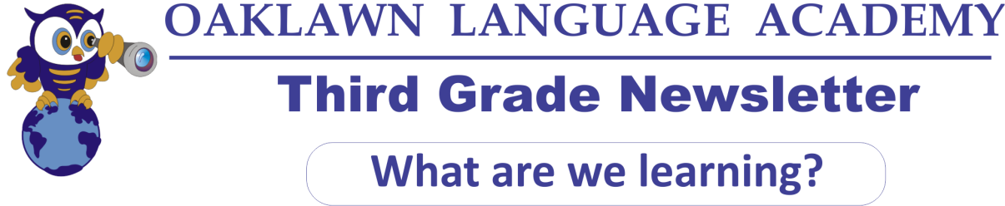
Math: This month We will be learning about collections and travel stories. We will focus on “How many tens in 3-digit numbers” and two-step problems. We will also be reviewing rounding numbers to nearest 10 and 100 and Elapsed Time. They have to be able to read the clock. For extra practice they can go to Ten Marks, compass learning (Math) and the third grade weebly. http://oaklawnthirdgrade.weebly.com/

Nov. 2016

Language Arts: This month in reading we will be learning about the main idea of a nonfiction text as well as, details that support the main idea. Students have already started learning about Non-fiction texts. We will be teaching the students about text features as well as, introducing them to Close reading passages.

Language Arts: This month in reading we will be learning about characters and their actions in the story. We will also be learning about sequencing events, and using fix-it strategies in our reading. Students will also begin our unit in writing about a small moment in their life.

Science: This month students will be learning about Energy. Students will be learning about conductors and insulators and how you can control the flow of heat. Students will also be learning about how energy can change matter.

Social Studies: This month we will be learning about the 3 types of government and the leaders. Vocabulary: federal government, state government, local government, president, governor, major. Please, visit the school weebly to practice the vocabulary.

Spanish: We have started using our new Spanish workbook. Students can practice grammar and writing.This month we will continue writing OLA questions. We will also be working on grammar (verbs “gustar” “ser” “estar” y “Tener”) and describing people and things. Description vocabulary (adjectives). We will also be working with reading comprehension text with questions. Please go to the weebly to watch videos and songs and to practice vocabulary go to www.quizlet.com

Important Information: Please be sure to check the Thursday Folder for quizzes and tests. All quizzes and tests need to be signed and returned the next class period. If tests are not signed and a retake is available the students will not be able to retake their test. Please be sure that your child is practicing at home with the resources we discussed with each of you at conferences.

DATES TO REMEMBER
8th | Teacher Workday
10th | Report cards will be sent home
11th | No School – Veterans Day
17th | Quarter 1 Awards Ceremony 9:30-10:30
23rd-25th | No school – Thanksgiving Break
