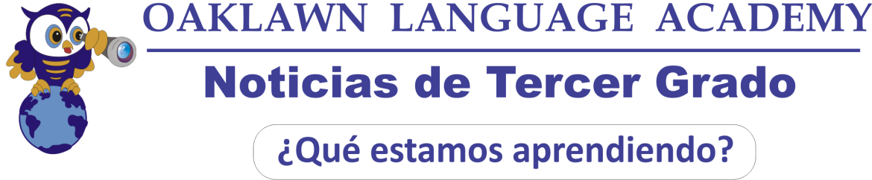
Matemáticas: Estaremos aprendiendo sobre Geometría: Los atributos de los polígonos, los diferentes tipos de ángulos y el perímetro de los polígonos. Seguiremos repasando “aproximar números a la decena y a la centena más cercana. También continuaremos practicando el valor numérico (unidades, decenas y centenas) y problemas relacionados con la hora. Deben saber leer el reloj. Para practicar matemáticas en casa los estudiantes pueden ir a Ten Marks y a la Weebly de tercer grado http://oaklawnthirdgrade.weebly.com/

OCT. 2016

Inglés: En lectura estaremos aprendiendo acerca de los personajes y cómo interactúan en la historia. Este mes también estaremos aprendiendo acerca de la secuencia de eventos y como usar estrategias en la lectura. Los estudiantes empezarán la unidad sobre escribir acerca de pequeños momentos en su vida.

Ciencias: Los estudiantes aprenderán acerca de la materia. Ellos aprenderán acerca de los sólidos, líquidos y gases. Los estudiantes también realizarán un taller de ciencias en la clase, patrocinado por Discovery Place acerca de la materia.

Sociales: Hemos comenzado la unidad: “Gobierno y Ciudadanos” Vocabulario: Bien común, voluntario, consecuencia, voto, elección, papeleta de voto, candidato, jurado, trabajador público, multa, impuesto, ley. Para practicar el vocabulario pueden ir a la weebly de tercer grado.

Español: Seguiremos escribiendo las preguntas OLA habla español. También trabajaremos en gramática (verbos gustar, ser y estar) y describiendo personas y cosas. Vocabulario para describir, adjetivos. También trabajaremos en comprensión lectora de un texto con preguntas y secuenciación de eventos en la historia usando los conectores al principio, en el medio y al final. Por favor vayan a la weebly de tercer grado para ver videos y canciones y para practicar vocabulario pueden ir a www.quizlet.com

Información Importante: Los estudiantes necesitan traer sus materiales cada día. Por favor asegúrense de mirar la Carpeta de los Jueves y firmar exámenes y papeles importantes y regresarlos el siguiente día. ¡Las conferencias empezarán este mes! Vamos a mandar un papel a casa pronto para que puedan apuntar un día y hora de su preferencia para la conferencia.

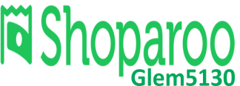  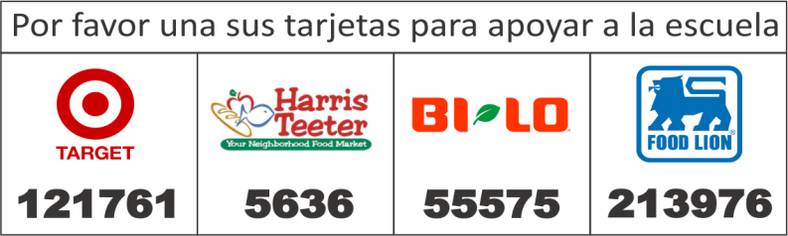 | FECHAS IMPORTANTES  11 Noche de Currículo.  12 Salida temprano  14 PTA Fiesta Latina 6:00 – 8:00  17 - 21 Semana de exámenes formales.  24 Noche en Cici’s Pizza University 6:00 – 9:00  28 Fin del primer bimestre  31 No hay clases
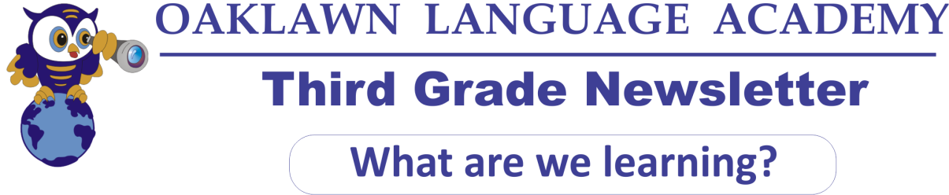
Math: We will be working on Geometry: The attributes of the polygons, the three types of angles and Perimeter of polygons. We will also keep reviewing rounding numbers to nearest 10 and 100, Place Value, counting coins and Elapsed Time. They have to be able to read the clock. For extra practice they can go to Ten Marks and the third grade weebly. http://oaklawnthirdgrade.weebly.com/

OCT. 2016

Language Arts: This month in reading we will be learning about characters and their actions in the story. We will also be learning about sequencing events, and using fix-it strategies in our reading. Students will also begin our unit in writing about a small moment in their life.

Language Arts: This month in reading we will be learning about characters and their actions in the story. We will also be learning about sequencing events, and using fix-it strategies in our reading. Students will also begin our unit in writing about a small moment in their life.

Science: This month students will be learning about Matter. Students will be learning about solids, liquids, and gases. Students will also be doing an in-school field trip through Discovery Place all about matter.

Social Studies: This month we will be learning about Civics and Governance: Good citizens, rights and responsibilities and Government. Vocabulary: Bien común, voluntario, consecuencia, voto, elección, papeleta de voto, candidato, jurado, trabajador público, multa, impuesto, ley. Visit third grade weebly to study the vocabulary “Good Citizens”

Spanish: This month we will continue writing OLA questions. We will also be working on grammar (verbs “gustar” “ser” y “estar”) and describing people and things. Description vocabulary (adjectives). We will also be working with reading comprehension text with questions and sequencing events (Al principio, en el medio y al final – At the beginning, in the middle and the end)
Please go to the weebly to watch videos and songs and to practice vocabulary go to www.quizlet.com

Important Information: Students need to have all of their materials with them every day. Please be sure to check the Thursday Folder for quizzes and tests. All quizzes and tests need to be signed and returned the next class period. Conferences will start this month! Please look for a paper to be coming home to sign up for a time to come in.

DATES TO REMEMBER
11 | Curriculum Night.
12 | Early Dismissal
14 | PTA Fiesta Latina Dance 6:00 – 8:00
17 - 21 | Formal Tests Week
24 | OWLS Night at Cici’s Pizza University 6:00– 9:00
28 | End of First Quarter
31 | Teacher Workday
